|  |  |
| --- | --- |
|  | **Sri Lanka Institute of Information Technology**  Temporary ID: Tmp/2020/32 |

Project Topic Assessment – 2020 Regular

Topic

Sinhala Conversational Appointment Management System for Medical Domain

Abstract (200 Words Max):

Most of the Medical systems are in the English language. In our country most of the middle aged and elders cannot understand English and they do not possess user experience about Information system. Most of the medical information system are now looking forward for automated Sinhala conversation system to help the customers (patients) to make a decision on their health issues. The system has the ability to satisfy users. This document presents a survey, starting from literature survey and research problem, solution, system overview diagram, system architecture diagram and technologies. The main objective of this system is developing an automated Sinhala conversation system for medical domain and as sub objectives semantic (voice) understanding, text (voice) processing, response generation, and training data.

Keywords -: RASA, NLU, NLP, AI

Research Area/Group: Select the area by referring to the document uploaded to the Courseweb

Robotics and AI

Supervisor:

Name: Prof.Koliya Pulasinghe

Added to the Project Registration System

(Signature)

Supervisor:

Research Problem:

Nowadays in Sri Lanka, all of the e-channeling systems are based on the English language. Mostly E-channeling systems are used by people in western province comparing to other provinces. The reason is the erudition that they have is very impecunious in the English language [1].

Sometimes, people having diseases such as Short-Term and Long-Term Incapacitation and People with dyslexia, are incapable of using communicate an E-channel system [1].

Most of the Sri Lankan E-channeling systems are web-predicated and utilizing the web-predicated system in mobile is Minimize Celerity, sometimes browser support is very impuissant and not facile to utilize on mobile. It is not user-friendly for mobile [2].

Most of the patients don't know what the specialization of the doctors is, and who are the best doctors of their diseases. They only know the diseases that they have at that moment [2].

Some of the patients know doctor's name but they will not know the details about the doctor, such as the hospital where, the doctor is available, time schedules of the doctors [3].

Some patients know all the details and they want to get an appointment with doctors, but they couldn't make it, because they will face interaction problems with a system, the system will perform the English language they can't understand it [3].

Patient have to pace on above difficulties in this kind of a challenging situation.

References

|  |  |
| --- | --- |
| [1] | "Chatbots: The next generation in computer interfacing – A Review," 2017. [Online]. Available: [http://ir.kdu.ac.lk/bitstream/handle/345/1669/003.pdf?sequence.](http://ir.kdu.ac.lk/bitstream/handle/345/1669/003.pdf?sequence) |
| [2] | "Chatbot : A Survey on Evaluation Methods for Chatbots," 7 march 2019. [Online]. Available: [https://www.researchgate.net/publication/333524709_A_Survey_on_Evaluation_Methods_for_Chatbots.](https://www.researchgate.net/publication/333524709_A_Survey_on_Evaluation_Methods_for_Chatbots) |
| [3] | "Survey on Intelligent Chatbots: State-of-the-Art and Future Research Directions," january 2020. [Online]. Available: [https://www.researchgate.net/publication/333931397_Survey_on_Intelligent_Chatbots_State-of-the-Art_and_Future_Research_Directions.](https://www.researchgate.net/publication/333931397_Survey_on_Intelligent_Chatbots_State-of-the-Art_and_Future_Research_Directions) |

Solution proposed:

There are several solutions to the problems identified in the research.

Human computer interaction (HCI) is a major role in interfaces between a human and machines. Dialogue system, conversational system, Chatbot, voice controller interface and personal assistants’ system are the example of HCI system that have been developed to Interaction with a human using Natural language. That type of system helps users (In our system user is a patients) to find a useful information for there needs. Thus, a number of hospital organizations prefer to use an automated system such as a chatbot to automate their customer service. Because that type of system is easy deliver to user. As the first solution, we identified develop a Chatbot for interaction with a patient.

For some disabled people who might struggle, or find it impossible, to work with a mouse or keyboard, speech recognition enables them to communicate with a system effectively. It lends a hand to those with physical impairments and dyslexia and also reduced time and it less stressful than conventional handwriting or typing. Therefore, as the second solution is which allows a user to perform voice commands such as text commands.

Today mobile usage is increased in the world, and most people are using smartphones. Also, Sri Lankan people are the same and most of them used an internet on their smartphones. As a solution, we developed a mobile app, which is easy to deliver a better service in patients.

In Sri Lankan population is 22,576,592 (July 2018 est.). in 87% percentage can speak the Sinhala Language. 23.8% lower percentage of people can speak the English language (2012 est.) and 91.9% percentage can read and write. (Copyright @ Department of Census and Statistics server details ) According to the survey Most of the Sri Lankan people can communicate and understand the Sinhala language. Thus, as the language problem solution is, we are using the Sinhala language. Therefore, we used Natural Language Processing (NLP). NLP is a way of computers to analyze, understand and derive meaning from a human language such as English, Sinhala and etc.

Thus, the need of using artificial intelligence has been increasing due to the needs of automated services. However, devolving smart bots that can respond at the human level is challenging. And it can give to user a better service and solve the user problem. In our research, we identified user problems, is getting doctor visiting appointments for patients. Our system provides information about doctors, hospitals, and channeling information allowing patients to easily make appointments.

System Overview Diagram for the solution proposed (Clearly indicate the main four components of the proposal)

Pre-Processing

User Interaction

Retrieved base

Already defined Data

Natural Language generation

Database and Knowledge

Generated query process & data retrieve

Sentence planning

Content Determination

Generative Base

TensorFlow

Natural language Processing

Answer of Medical issue

Processing

Identified Similarity

Intent Classification

Natural language Understanding

Identified Key Entity

User Interface

Patten Matching

Input of Medical issue

Voice Processing

Understanding Natural Language

Type

Rule Base

AI Base

Voice to text

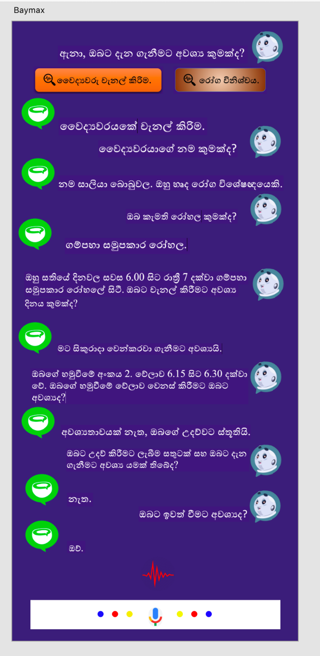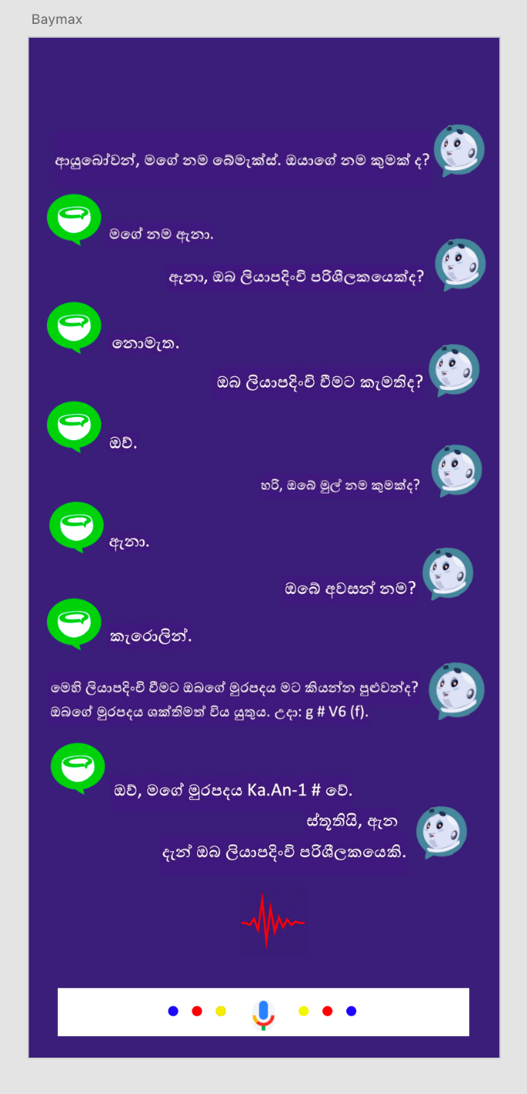

For more reference : <https://xd.adobe.com/view/0cc10a82-3ab7-4689-621b-28c7134294d5-7af0/>

Objectives (1 main objective and 4 sub objectives):

Main Objective: Beyond Patient E-channeling Monitoring: Automated Conversational Agents Role in artificial intelligence & Healthcare Support for Patient and receptionist.

The required doctor Channeling by Patient.

* 1. The patient doesn't have a clear idea (Time, Place, Doctor, Diseases).
  2. The patient has a clear idea.

Sub Objective 1: Understanding user Natural Language.

* User will be giving the medical questions in voice command and system will be wanting to understand the user Natural Language.
* Therefore,
  + Getting user speech audio file.
  + Audio convert to text file.
  + Sinhala Text convert to English phonetic.
  + Store in database.
  + Develop the Sinhala Phonetic Dictionary for user.

Sub Objective 2: Natural Language Process.

* After understanding the Natural Language, system have to identify the medical terms key words.
* Then system will be processing the similarities and the dissimilarities of the medical terms.
* Generate a query
* Generate a Blockchain for user appointment

Sub Objective 3: Connecting an NLU into Rasa framework.

* Retrieve the database knowledge for the above Natural Language Process.
* NLU (Extracted the data RASA NLU)
* Training medical terms Data using Json Format and TensorFlow.

Sub Objective 4: Dialogue management of Bot

* According to the trained metical terms knowledge, generate the answer for the medical questions to user.
* Therefore, we have to develop the Sinhala Model for Bot

Task List divided among the members

Beyond Patient E-channeling Monitoring: Automated Conversational Agents Role in artificial intelligence & Healthcare Support for Patient and receptionist.

Industry data (E-Channeling system):

The required doctor Channeling by Patient.

* 1. The patient doesn't have a clear idea (Time, Place, Doctor, Diseases).
  2. The patient has a clear idea.

System Overview Description

* There are four micro-services throughout the system.

1. Channeling information (MySQL database)
2. User registration (MySQL database)
3. Elastic Kibana mapping db. (Channeling, User Registration) - accurate search query, easy to store historical data.
4. Identify medical domain key factors

* Interfaces designed using React-Redux

Member 1(IT16234062)

* Understanding user Natural Language.
  + Initially user will enter the voice input,
  + System will be recoding and save it in volatilely.
  + And Audio convert into proper Sinhala sentence with Sinhala characters.
  + Create Sinhala Phonemes Dictionary and training. That Dictionary using convert Sinhala text into English text.
  + And that data inserts into Database.

Member 2(IT17255820)

* Natural Language Process.
* Then system will process the important facts of that Sinhala sentence. Through the identified facts will be generate a Query. And Generate a Blockchain for user appointment

Member 3(IT17043656)

* Connecting an NLU into Rasa framework
* Using the generated query, data will be retrieved from Elastic Kibana database.

Retrieved data will be trained using TensorFlow and json format.

After that extract the data to RASA NLU.

Member 4(IT17029278)

* Dialogue management of Bot
* Using that RASA NLU generate the dialogue. Response speech will be generated.

To do want to create the Sinhala Model for Text to speech.

Technologies to be used:

* **RASA**

This open source machine learning framework for building AI assistants and chatbots.

* **RASA-X**

It’s a tool that helps to build, improve and deploy AI assistants that are powered by the RASA framework

* **Python**

This interpreted, high-level, general-purpose programming language helps to develop RASA AI assistants and chatbots

* **RASA NLU (Natural Language Understanding)**

Tool for understanding what is being said in short pieces of text.

* **NLP (Natural Language Processing)**

Tool for intent classification, response retrieval and entity extraction in chatbots.

* **Elastic Kibana**

This open source and virtualization platform use to mapping the databases which are created in MySQL

* **MySQL**

This open source relational database management system is use to store the medical terms data which are gathered from our survey

* **Mozilla Deep Speech**

It’s an automatic speech recognition (ASR) engine which aims to make speech recognition technology and trained models openly available to developers

* **Mozilla TTS**

Aims a deep learning-based Text to Speech engine, low in cost and high quality. To being with, you can hear a sample generated voice from here.

* **RASA Core**

It’s a dialogue engine for building AI assistants

* **JAVA**

Is a general-purpose programming language for develop web services?

Team Members:

|  |  |
| --- | --- |
| Student Name | Student ID |
| Leader: Rajapakshe D.D.S | IT16234062 |
| Member 2: U.L.N.P. Uswatte | IT17029278 |
| Member 3: Kudawithana K.N.B | IT17255820 |
| Member 4: Nishshanka N.A.B.D | IT17043656 |

**For official use only**

Acceptable: YES/NO

Minor Corrections (if necessary)

Major changes proposed: ____________________________________________________________________________________________________________________________________________________________________________________________________________________________________________________________________________________________________________

Any other Comments: _________________________________________________________________________________________________________________________________________________________________________________________________________________________________

Approved by the review panel:

|  |  |
| --- | --- |
| **Member’s Name** | **Signature** |
|  |  |
|  |  |
|  |  |

**Important**:

1. According to the comments given by the panel, do the necessary modifications and get the approval by the **same panel**.
2. If the project topic is rejected, find out a new topic and inform the CDAP Group for a new topic pre-assessment.
3. A form approved by the panel must be attached to the **Project Charter Form**.